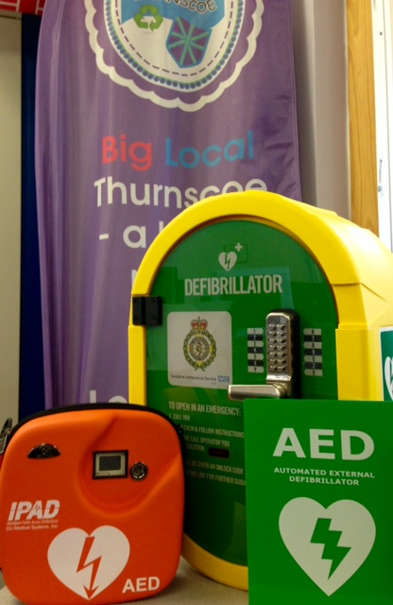
Defibrillator Awareness Session
We now have a new community AED installed outside the ‘One Stop’ on Shepherd Lane in Thurnscoe. Big Local Thurnscoe invites you to find out how easy it is to use this vital equipment and be ready to save a life! Free session and refreshments:
Wednesday 2nd August 10.30- 11.30 Thurnscoe Library- all welcome
Yorkshire Ambulance Service will be here to demonstrate equipment usage and answer your questions.

